
BING HAN
Software Change Specification
Revision History
Version | Author | Date | Remarks
1.0 | Livin C J | 25-04-2020 | - Create VIP Users by Admin.  - Create VIP Products and Special Price.  - VIP user login and purchase.
1.1 | Livin C J | 05-06-2020 | - VIP user login page changes  - Create Privacy Policy & Legal Ad information
1.2 | Livin C J | 09-06-2020 | - VIP user registration by users  - Approval by Administrator  - Send mail to VIP user after confirmation  - Design changes in VIP Login page & Terms & Condition
1.3 | Livin C J | 24-06-2020 | - Changes in VIP Registration

Software Change specification for Binghan.

Table of Contents

Table of Contents 2
1 SCOPE 3
1.1 DETAILS 3
CHANGE Requirements – 25/04/2020 3
1.2 ISSUES TO BE RESOLVED 3
1.3 PROPOSED CHANGE PLAN 3
2. USER LOGIN 4
4
ADMIN 7
1.4 DATABASE CHANGES REQUIRED 8
CHANGE Requirements – 05/06/2020 9
CHANGE VIP LOGIN 9
CHANGE Requirements – 09/06/2020 10
1 VIP RegistrATION 10
2 AdminISTRATOR 13
CHANGE Requirements – 24/06/2020 13
1 VIP Register 13
2 Admin 16

SCOPE

DETAILS

BINGHAN is a Customized Ecommerce site for Japanese client. Registered users can view and purchase all the products. Each user has a separate portal to view their cart, ordered list, and account. This system is helping every user to purchase in home.

CHANGE Requirements – 25/04/2020

ISSUES TO BE RESOLVED
Create a VIP member’s Login.
Admin side changes

PROPOSED CHANGE PLAN
Create additional module for VIP Member with following features.
Admin
- VIP User Registration
- Add VIP Products
- Set VIP Rates for products
Users (VIP)
- User Login
- User Profile Page
- View the products
- Buy the products

2. USER LOGIN

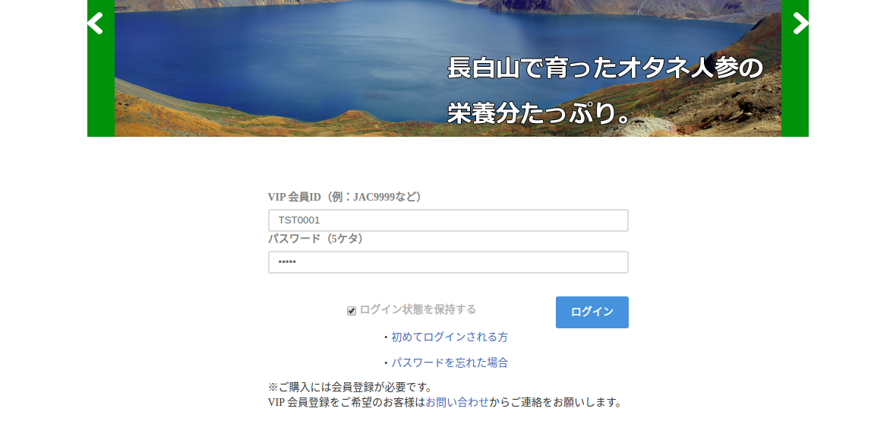
VIP REGISTRATION
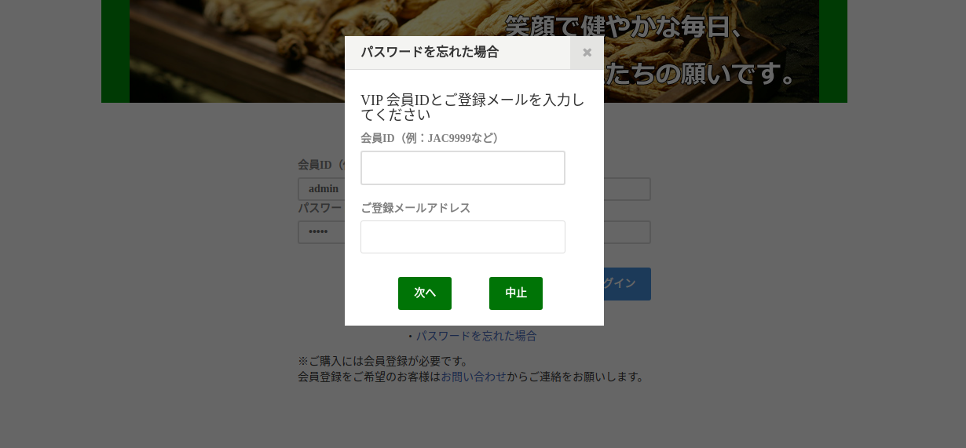

VIP PURCHASE
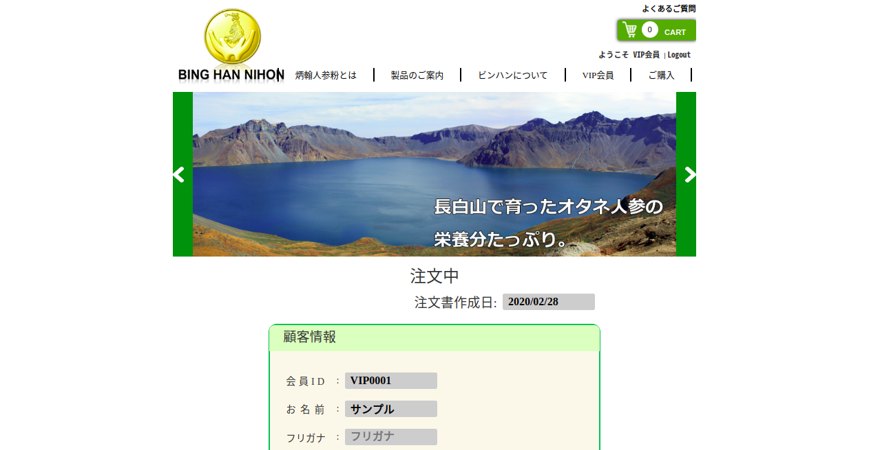
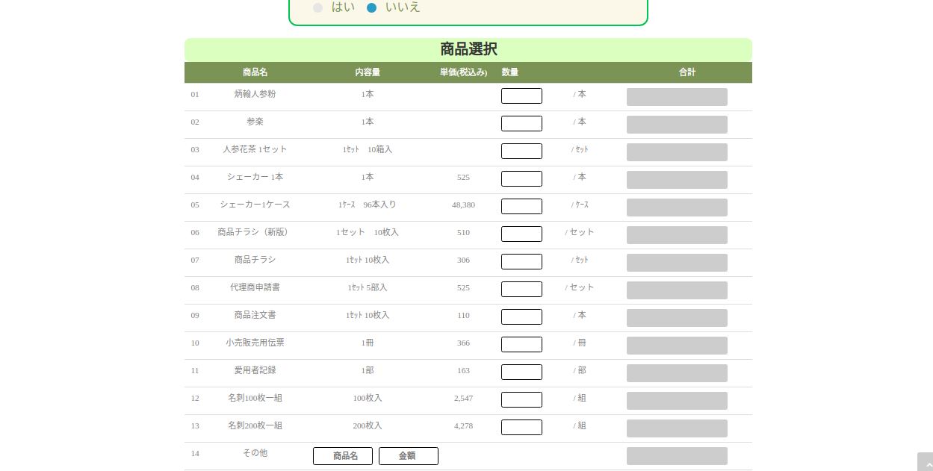

USER PROFILE

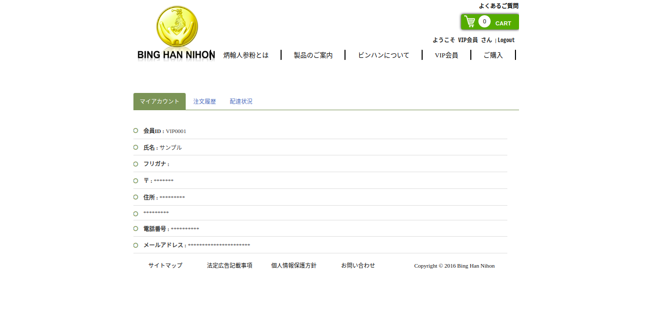
PRODUCT PAGE - POPUP
炳翰人参粉 has an image display pop up. The picture provides guidance on how to use that product.

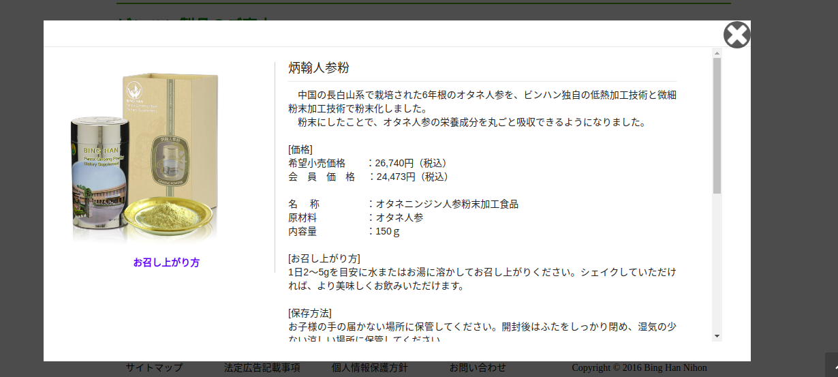

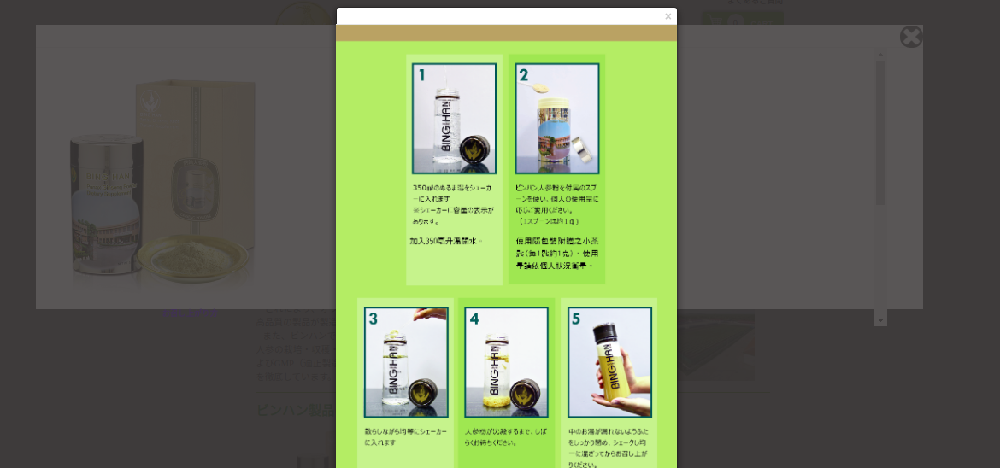

ADMIN
Add VIP member
Select the customer type when adding a new customer. There are two user types, normal user and VIP user.
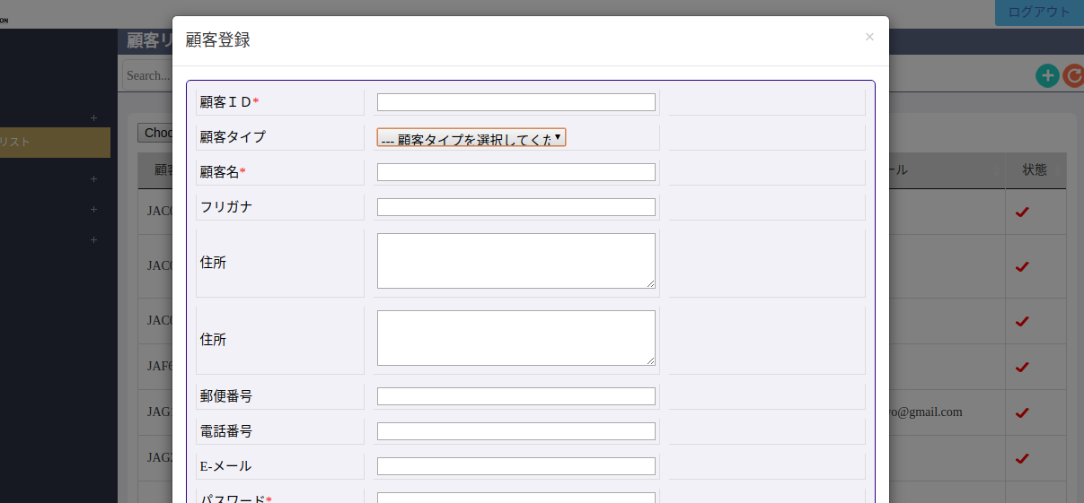

Add VIP products
Select the product type when adding a new product. There are two user types, normal user and VIP products. VIP offer only for VIP products.
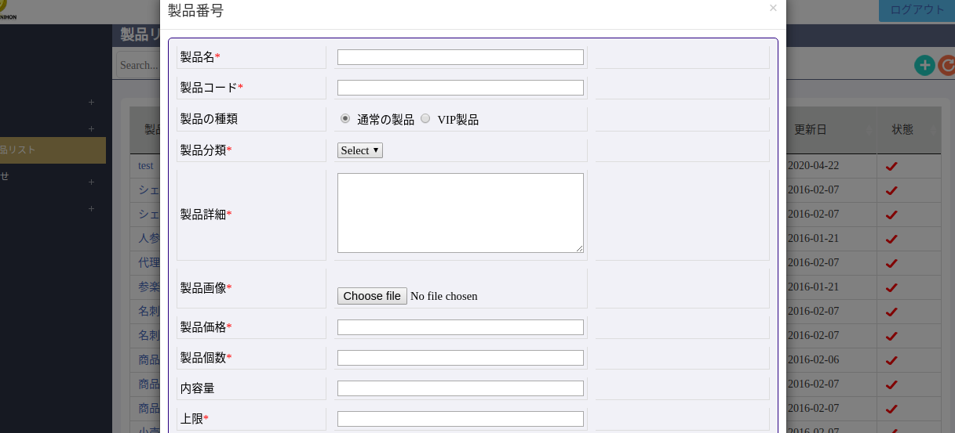
Add new tab for VIP product rate

Here is the system of VIP rates. This particular calculation is for VIP members only.

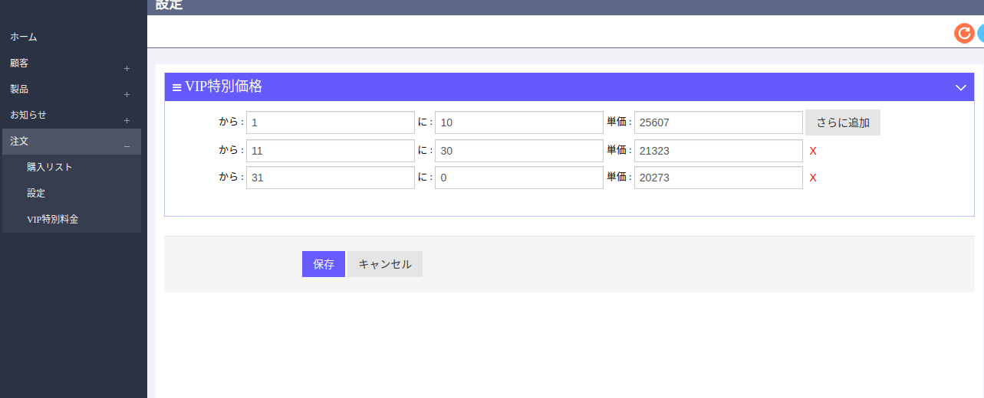

DATABASE CHANGES REQUIRED
1. Modify Table - Customers
user_type, varchar, 25
2. Modify Table - Product
product_type, tinyint, 55
3. New Table - vip_price_setting
Id, int, 11
qty_from, int, 155
qty_to, int, 155
amount, int, 255

CHANGE Requirements – 05/06/2020

CHANGE VIP LOGIN
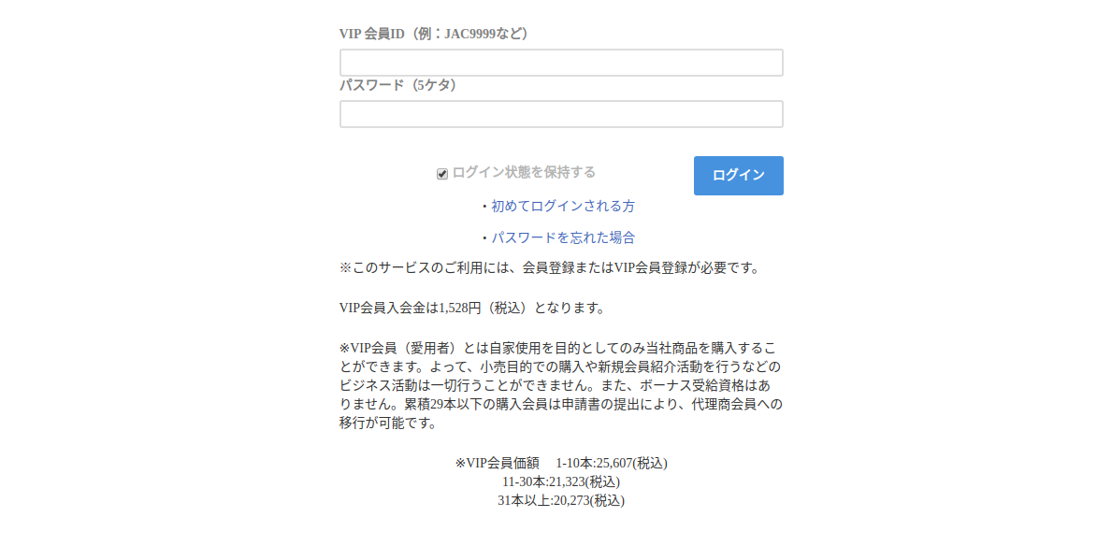
When the user first logs in, it is redirected to the Privacy Policy and the Legal Ad Information page. There is a check box that accepts the terms of the Privacy Policy.

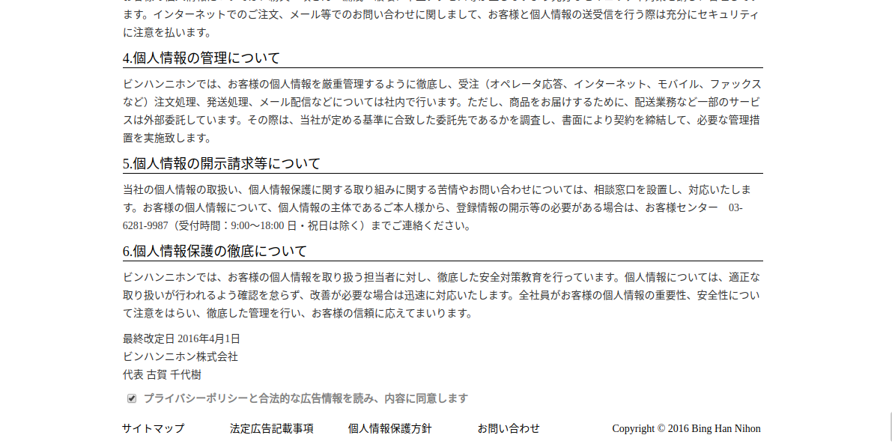
Only redirect to home after agree the terms and condition.

CHANGE Requirements – 09/06/2020

VIP RegistrATION
Initially the user can register as VIP member with Name, Email, Phone and Password (5 digits).
Later the administrator will approve and provide the Member ID through registered mail.
1.1 Agree the privacy and Legal advertisement information
While registration, user will first redirect to the privacy and Legal advertisement information:

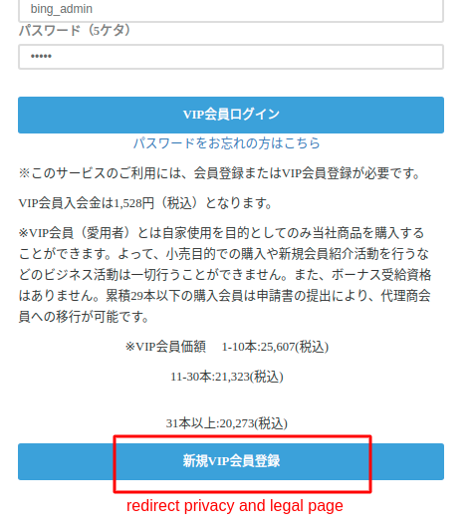

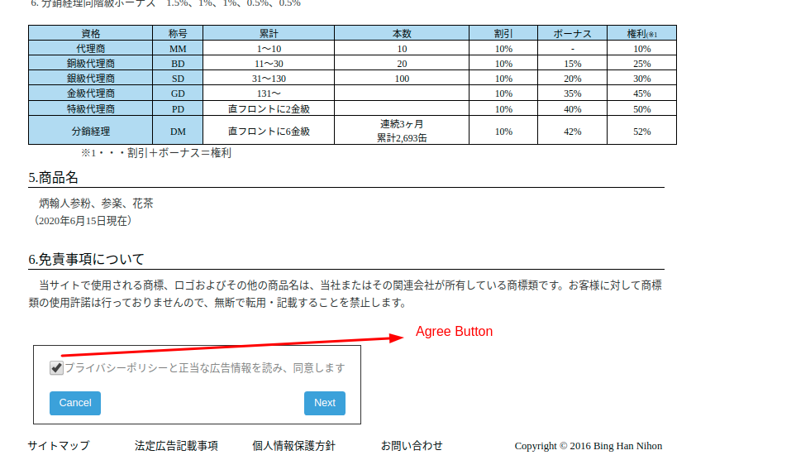
For agreement confirmation a “Next” button has been provided. Users can go to the VIP registration page by clicking on the "Next" button.
1.2 VIP Registration
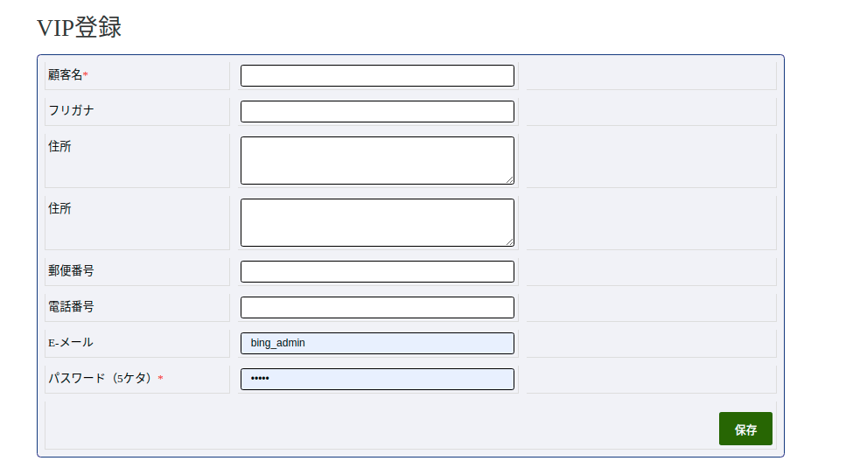
Fill out the registration form with Name, Email, Phone, and Password (5 digits).

AdminISTRATOR
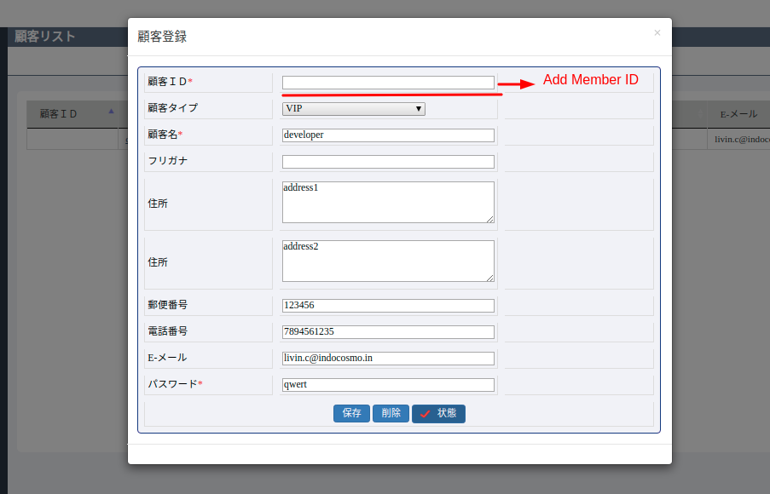
2.1 Pending Approval List
Administrator can view the pending list of VIP registrations here. Admin can select each users and provide the Member ID. An email will be sent to the user as below:
Sub: VIP REGISTRATION COMPLETED
Your registration process has been completed.
Please use the following details for login:
VIP member ID :TST014149
Password: as123

CHANGE Requirements – 24/06/2020

VIP Register
Here user can Register with their Name, email, phone and Password (5 digits). The users get their Member ID through registered mail after Admin approval.
1.1 Agree the privacy policy
Redirect to the privacy and Legal advertisement information by click

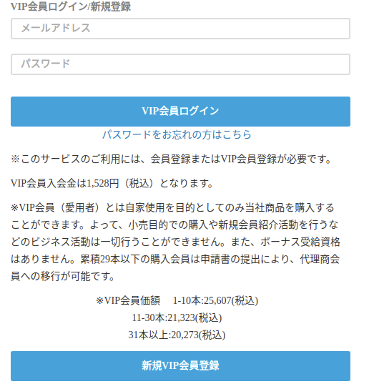

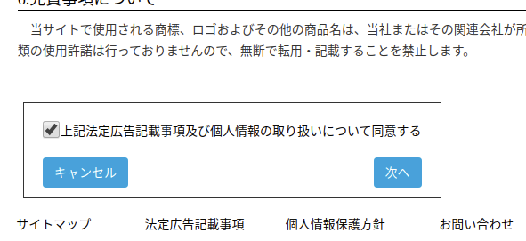
The “Next” button appears by agreeing to privacy and legal agreements. Users can go to the VIP registration page by clicking on the "Next" button.

1.2 VIP Registration
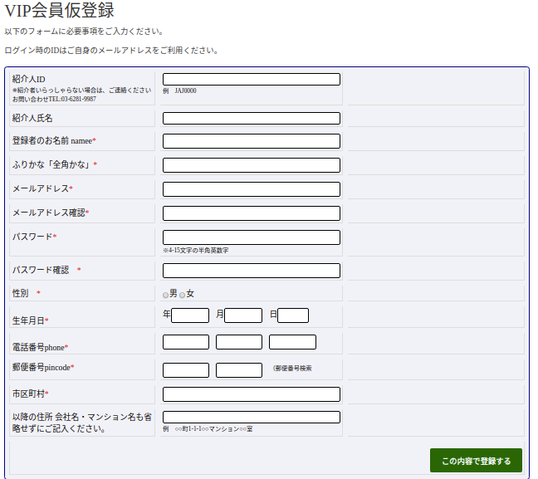
Registration form with Name, Email, Phone, Password (5 digits).

Admin
2.1 Pending Approval List
You can view the pending authorization list of VIP user here. No member ID. Admin can click on username to add member ID.

